School Climate Module Access

In addition to accessing the School Climate Module Series on the Delaware PBS website, they are also available through:
- Courses through PDMS
- A Schoology group: “School Climate Professional Development”
  - Access code: 2P5NM-F56JT

1. Accessing the modules as courses through PDMS
- Each module is worth 1 clock-hour
- Videos are divided into segments – total time is 40-50 minutes
- Resources are organized by corresponding video segment
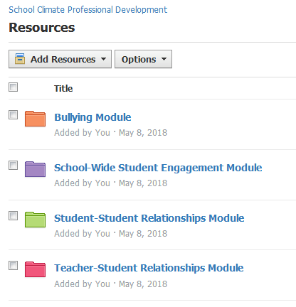
- Complete follow-up quiz and endorse verification statement in order to receive credit!

2. Accessing the modules on Schoology
- All available modules are accessible in the Resources folder of the School Climate Professional Development group

- Each module contains:
  - Introduction and Course Content
  - Information presented via video
  - Resources
  - Research
  - Comments & Discussion section
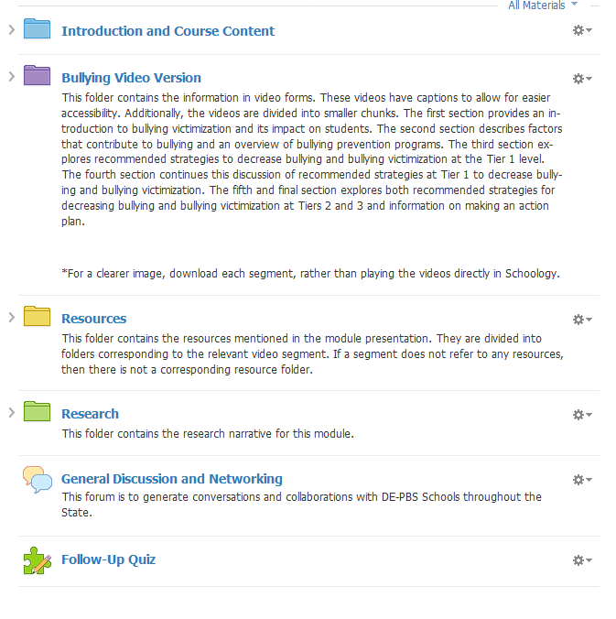
  - Participant Quiz/Feedback

