__________’s Day of ZONES
Blue Zone | Green Zone | Yellow Zone  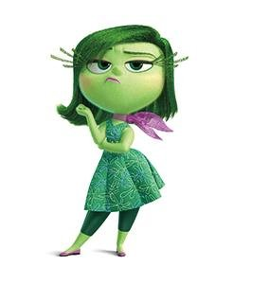 | Red Zone  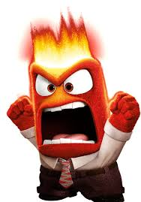
When this happens… | When this happens… | When this happens… | When this happens…
I might feel… | I might feel… | I might feel… | I might feel…
I might look/sound like… | I might look/sound like… | I might look/sound like… | I might look/sound like…
I can… | I can… | I can… | I can…

