"Top 10 Ideas for Rebooting "
Reinvigorating PBS
at the Secondary Level

Project Ideas
1 | Reboot Your Team
2 | Use Your Data
3 | Start with Staff
4 | Steps Toward Check In – Check Out
5 | Nominate a Classroom of the Week/Month
6 | Tardy Intervention
7 | Have a Monthly Theme
8 | Positive Behavior Referrals
9 | Get the Students “Plugged In”
10 | Growth Mindset

Peer Ideas

Helpful Websites:

www.pbis.org/school/high-school-pbis
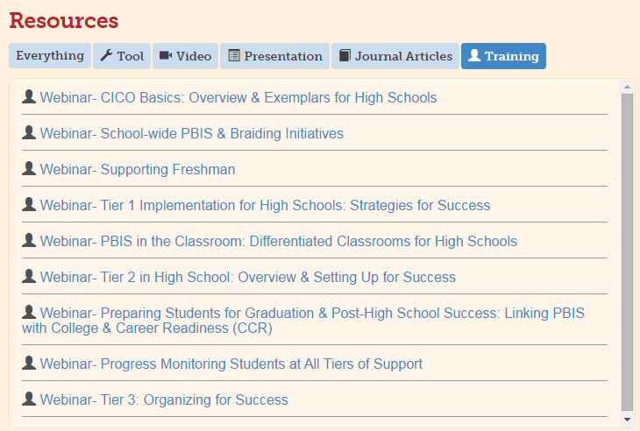

http://www.midwestpbis.org/high-schools
CICO Basics: Overview & Exemplars for High Schools Ali Hearn, Midwest PBIS Network
An overview of CICO including the “how to” of practices, systems requirements, and an example of application in high school.
School-wide PBIS & Braiding Initiatives Stephanie Martinez, Florida PBIS
An overview and examples of aligning initiatives successfully within the SWPBIS framework and maximizing current systems.
Supporting Freshman Patti Hershfeldt, Maryland PBIS, & Mimi McGrath Kato, University of Oregon
Research based strategies and systems for providing developmentally appropriate to your most vulnerable grade level.
PBIS in the Classroom: Differentiated Classrooms for High Schools Jessica Swain-Bradway, Midwest PBIS Network Environmental and instructional strategies for boosting self-management and engagement.
Tier 1 Implementation for High Schools: Strategies for Success Jessica Swain-Bradway, Midwest PBIS Network An overview of Tier 1 including common obstacles to success and how high schools around the country have strategized to overcome those obstacles.
Tier 2 in High School: Overview & Setting Up for Success Jessica Swain-Bradway, Midwest PBIS Network
Essential features of any Tier 2 intervention, interventions specific guidelines, and examples of problem solving common obstacles.
Preparing Students for Graduation & Post-High School Success: Linking PBIS with College & Career
Readiness (CCR) Jennifer Freeman & Allison Lombardi, Center for Behavioral Education & Research (CBER)
Information on integrating CCR behaviors into school-wide expectations/rules and universal screening of non-academic factors.
Progress Monitoring Students at All Tiers of Support Jessica Swain-Bradway & Ali Hearn, Midwest PBIS Network School-wide guidelines and daily strategies for progress monitoring within the high school setting.
Tier 3:Organizing for Success
Jessica Swain-Bradway, Midwest PBIS Network
Effective Tier 3 interventions require systems alignment, expanded school teams, and a “stay at the table” mentality. Join this webinar for guidelines in building and “boosting” Tier 3 within your high school.

