PTR ACTIVITY PACKET
Activity Packet-Table of Contents

Teaming Collaboration Activity | 3
Step 1 Activity-Paris Short Term Goals | 4
Step 1 Activity-IBRST | 5
Step 2 Activity-Dot Connection | 6
Step 2 Activity-Paris Assessment Summary Table | 7 - 8
Step 2 Activity-Assessment Summary Table Cheat Sheet | 9
Step 3 Activity-Paris Intervention Plan | 10

PTR Step 1: Developing Short Term Goals for Paris
Activity 2b

BEHAVIORS TO DECREASE
Target Behavior: | Operational Definition:
BEHAVIORS TO INCREASE
Target Behavior: | Operational Definition:

Step 1: Individualized Behavior Rating Scale Tool (IBRST)

Student: School: Teacher(s):

Target Behavior |  | Date
 |  |  | 5  4  3  2  1 | 5  4  3  2  1 | 5  4  3  2  1 | 5  4  3  2  1 | 5  4  3  2  1 | 5  4  3  2  1 | 5  4  3  2  1 | 5  4  3  2  1 | 5  4  3  2  1 | 5  4  3  2  1 | 5  4  3  2  1 | 5  4  3  2  1 | 5  4  3  2  1 | 5  4  3  2  1 | 5  4  3  2  1 | 5  4  3  2  1 | 5  4  3  2  1 | 5  4  3  2  1 | 5  4  3  2  1
 |  |  | 5  4  3  2  1 | 5  4  3  2  1 | 5  4  3  2  1 | 5  4  3  2  1 | 5  4  3  2  1 | 5  4  3  2  1 | 5  4  3  2  1 | 5  4  3  2  1 | 5  4  3  2  1 | 5  4  3  2  1 | 5  4  3  2  1 | 5  4  3  2  1 | 5  4  3  2  1 | 5  4  3  2  1 | 5  4  3  2  1 | 5  4  3  2  1 | 5  4  3  2  1 | 5  4  3  2  1 | 5  4  3  2  1

KEY:
Problem Behavior : Definition Time/Routine: All day Specific Time/Routine:
5 = Terrible day
4 = Typical bad day
3 = So-so day
2 = Good day
1 = Fantastic day

Replacement/Alternate Desired Behavior; Definition Time/Routine: All day Specific Time/Routine:
5 = Fantastic day
4 = Good day
3 = So-so day
2 = Typical bad day
1 = Terrible day

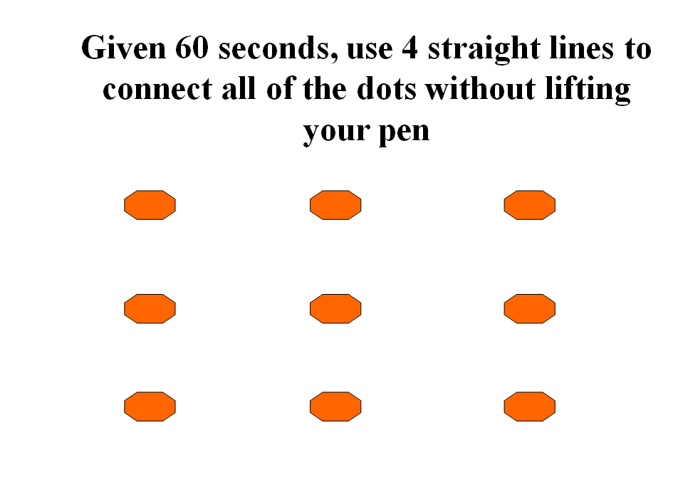
Step 2: Activity
PTR Functional Behavior Assessment Summary Table

Student: Paris School: Cotton Candy Date: 2/26/06

Behavior | Antecedent/Prevent Data | Function/Teach Data | Consequences/Reinforce Data
Call-outs | Tasks  - Independent work—specifically when seatwork  - Teacher led lessons—academics both whole and small group  - Non-preferred activities—activities that involve paper/pencil, academic content (reading and lang.arts)  - Given demands/requests to start working  - During transitions between activities-specifically from preferred to non-preferred  Setting events:  - When Paris is fatigued (sleep deprived), behavior more likely to occur | - Get attention from any peer or any adult  - Structured activities—wanting to terminate (incomplete work or illegible); wants to be ‘done’;  - Transition: Wanting to rush to next task; terminate reading and writing to go to centers | - Redirection or reminders  - Gets reactions from peers)  - Seat location changed (moved away from other students)  - Stays in from preferred activities (specials, recess) to complete work (when this happens, she has one-to-one attention with teacher or other adult)
Pro-social | Activities  - Computer, center time (spelling stamps, listening center, computer, listen and learn), math  Classroom arrangement  - Teacher proximity (close by) | Desired Skills to be taught  - Social skills  - Problem solving  - Getting attention in appropriate ways  - Asking questions when appropriate  - Staying on task and completing work  - Complying with instructions | - Social time with teacher and staff  - Computer  - Playing games  - Outside activities

Step 2: Activity
Hypothesis for Paris

Possible Hypotheses
 | When…. | He/she will….. | As a result, he/she ……
Problem Behavior |  | Call out
Replacement Behavior

Step 2: PTR Functional Behavior Assessment Summary Table: “Cheat Sheet”

Student: ____________________________ School: ___________________________________ Date: _____________________

 | Behavior | Prevent (Antecedent) Data | Function (Teach) Data | Consequences (Reinforce) Data
Problem behavior | Name of problem behavior | Include information from the Prevent component of the PTR assessment (items #1a, 2a, 3a, 4, 5, 6) | Include information from the Teach component of the PTR assessment (items #1 through #6) | Include information from the Reinforce component of the PTR assessment (items #1 & 4)
Appropriate behavior | Name of pro-social or replacement behavior | Include information from the Prevent component of the PTR assessment (items #1b, 2b, 3b) | Include information from the IBRST or other sources that provide the replacement behaviors;  (if student PTR used, items #7, 8, 9). | Include information from the Reinforce component of the PTR assessment (items #2, 3, & 5)

Possible Hypotheses
 | When…. | He/she will….. | As a result, he/she ……
Problem Behavior | Include the relevant data from the problem behavior prevent data above | Behavior being evaluated | Function (from problem behavior teach data)
Replacement Behavior | Copy what you have in the row above (problem behavior when) | Write in the new behavior/skill or, replacement behavior | Copy what you have in the row above (problem behavior function).

Activity Step 3:
PTR Behavior Intervention Plan—Paris

Hypothesis:

TEACH Behavior Interventions

Intervention | Specific Steps
Prevention | Steps:
Teach Replacement Behavior  (choice between raising hand, requesting attention, academic engagement) | Steps:
Reinforce Replacement Behavior | Steps:

